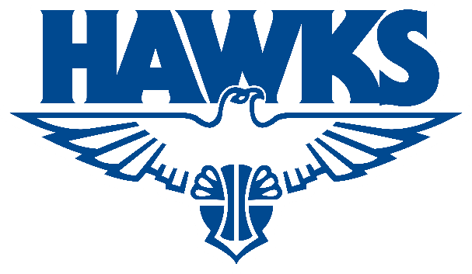
Refund Policy
PLHBA Policy – Refunds

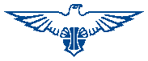
UPDATED: January 2026

Perry Lakes Hawks Basketball Association Inc.
ABN: 65 140 754 146

CONTENTS

1. OVERVIEW 3
2. JUNIOR DOMESTIC COMPETITION 3
3. JUNIOR DEVELOPMENT LEAGUE 3
4. WABL 4
5. STATE CHAMPIONSHIPS 4
6. AUSSIE HOOPS 4
7. COURSES 5

OVERVIEW

  - This policy outlines how registered participants or members can request refunds if they withdraw from a competition, program, course or event.

  - All registered participants or members must meet the eligibility criteria to be eligible for a refund.

  - Refund amounts are less any PlayHQ, Basketball WA or Basketball Australia Fees.

  - PlayHQ Registration Protection is not affiliated with PLHBA in anyway and are processed directly by PlayHQ.

JUNIOR DOMESTIC COMPETITION

  - Any registered player in the Junior Domestic Competition who withdraws permanently prior to the conclusion of round 3 will be eligible for a partial refund of their Perry Lakes Hawks Basketball Association Player Fee.

    - To request a refund, the registered player must email their Domestic Club to receive a Refund Request Form.

    - Once the registered player has sent the completed Refund Request back to the Domestic Club, they will sign and submit the request to the PLHBA via email to be processed.

  - The following eligibility criteria must be met for a refund to be approved.

    - PLHBA will refund the registered player’s Association Player Fee less 10% when they withdraw permanently from the Junior Domestic Competition prior to the initial fixtures being released.

    - PLHBA will refund the registered player’s Association Player Fee less 50% when they withdraw from the Junior Domestic Competition prior to the conclusion of round 3.

    - Refunds may be considered for special circumstances such as season ending injury/illness or relocation with consultation from the relevant Domestic Club.

      - For special circumstances involving injury or illness, a doctor’s medical certificate will be required.

JUNIOR DEVELOPMENT LEAGUE

  - Any registered player in the Junior Development League who withdraws permanently prior to the conclusion of round 3 will be eligible for a partial refund of their Perry Lakes Hawks Basketball Association Player Fee.

    - To request a refund, the registered player must email the PLHBA to receive a Refund Request Form.

    - Once the registered player has sent the completed Refund Request back to the PLHBA via email, the request will be processed.

  - The following eligibility criteria must be met for a refund to be approved.

    - PLHBA will refund the registered player’s Association Player Fee less 10% when they withdraw permanently from the Junior Development League prior to the initial fixtures being released.

    - PLHBA will refund the registered player’s Association Player Fee less 50% when they withdraw from the Junior Development League prior to the conclusion of round 3.

    - Refunds may be considered for special circumstances such as season ending injury/illness or relocation.

      - For special circumstances involving injury or illness, a doctor’s medical certificate will be required.

WABL

  - Any registered player in WABL who withdraws permanently prior to the conclusion of round 3 will be eligible for a partial refund of their Perry Lakes Hawks Basketball Association Player Fee.

    - To request a refund, the registered player must email the PLHBA to receive a Refund Request Form.

    - Once the registered player has sent the completed Refund Request back to the PLHBA via email, the request will be processed.

  - The following eligibility criteria must be met for a refund to be approved.

    - PLHBA will refund the registered player’s Association Player Fee less 10% when they withdraw permanently from WABL prior to the publication of WABL Grading fixture by BWA.

    - PLHBA will refund the registered player’s Association Player Fee less 50% when they withdraw from WABL prior to the conclusion of round 3.

    - Refunds may be considered for special circumstances such as season ending injury/illness or relocation.

      - For special circumstances involving injury or illness, a doctor’s medical certificate will be required.

STATE CHAMPIONSHIPS

  - Any registered player in State Championships who withdraws permanently prior to the publication of fixtures will be eligible for a partial refund of their Perry Lakes Hawks Basketball Association Player Fee.

    - To request a refund, the registered player must email the PLHBA to receive a Refund Request Form.

    - Once the registered player has sent the completed Refund Request back to the PLHBA via email, the request will be processed.

  - The following eligibility criteria must be met for a refund to be approved.

    - PLHBA will refund the registered player’s Association Player Fee less 25% when they withdraw permanently from State Championships prior to the publication of the fixtures by BWA.

    - Refunds may be considered for special circumstances such as season ending injury/illness or relocation.

      - For special circumstances involving injury or illness, a doctor’s medical certificate will be required.

AUSSIE HOOPS

  - Any registered participant in Aussie Hoops who withdraws permanently prior to the commencement of the second session will be eligible for a partial refund of their Aussie Hoops Participant Fee.

    - To request a refund, the registered participant must email the PLHBA to receive a Refund Request Form.

    - Once the registered player has sent the completed Refund Request back to the PLHBA via email, the request will be processed.

  - The following eligibility criteria must be met for a refund to be approved.

    - PLHBA will refund the registered participants Aussie Hoops Participant Fee less 10% when they withdraw permanently from Aussie Hoops prior to the commencement of the first session.

    - PLHBA will refund the registered participants Aussie Hoops Participant Fee less 25% when they withdraw permanently from Aussie Hoops prior to the commencement of the second session.

    - Refunds may be considered for special circumstances such as season ending injury/illness or relocation.

      - For special circumstances involving injury or illness, a doctor’s medical certificate will be required.

COURSES

  - Any registered participant in a PLHBA Course who withdraws permanently prior to the date of the course will be eligible for a partial refund of their Course Fee.

    - To request a refund, the registered participant must email the PLHBA to receive a Refund Request Form.

    - Once the registered participant has sent the completed Refund Request back to the PLHBA via email, the request will be processed.

  - The following eligibility criteria must be met for a refund to be approved.

    - PLHBA will refund the registered participants Course Fee less 25% when they withdraw permanently prior to the date of the course.

    - Refunds may be considered for special circumstances such as season ending injury/illness or relocation.

      - For special circumstances involving injury or illness, a doctor’s medical certificate will be required.

